2022 Data Management Workshop: RMarkdown

Knit to Word Demonstration

Jason Ross & Jacob Cochran

April 26 2022

Table of Contents

Introduction 2

Tables 2

Kable Package 2

Flextable Package 3

Plots 3

ggplot2 3

ggplot counts 3

# Introduction

This document demonstrates how to render a Word document using **RMarkdown** ([RMarkdown Cheat Sheet](https://www.rstudio.com/wp-content/uploads/2015/02/rmarkdown-cheatsheet.pdf)) and provides a few helpful links. Rendering a Word document can be challenging to format in R, especially when trying to format a table. Unlike rendering a PDF where you can format the document in the R script, it is better to format a reference document that can be used to format the document you are rendering ([Formating a Word document article](https://rmarkdown.rstudio.com/articles_docx.html)). We will step through the process to generate and use the reference document today. For more complex documents, I would recommend checking out the following packages:

Other packages that may help:

1. [Bookdown](https://bookdown.org/)
2. [officedown](https://ardata-fr.github.io/flextable-book/index.html)

# Tables

There are a few packages that can handle tables in word ([Comparison of Packages](https://cran.r-project.org/web/packages/gtsummary/vignettes/rmarkdown.html)) with varying capabilities. The kable package can be used for simple tables while the huxtable package uses the flextable package. Therefore, the flextable package is best suited for formatting a table when rendering a document to word. Here are a few links that are helpful when using the flextable package:

* Flextable Resources:
  + <https://ardata-fr.github.io/flextable-book/>
  + <https://davidgohel.github.io/flextable/reference/index.html>

## Kable Package

Table 1. This is a nice table using kable.

|  |  |  |  |
| --- | --- | --- | --- |
| Year | 16’ Bottom Trawl (4.9 m) | Boat Electroshocker | Fyke Net |
| 2018 | 120 | 60 | 60 |
| 2019 | 123 | 60 | 60 |

## Flextable Package

**Table** **1**: This is a nice table using the flextable package.

| Year | Bottom_Trawl | Electrofishing | Fyke Net |
| --- | --- | --- | --- |
| 2018 | 120 | 60 | 60 |
| 2019 | 123 | 60 | 60 |
| **Total** | **243** | **120** | **120** |

# Plots

## ggplot2

Embedding a figure is more straight forward than generating tables. The same package can be used to generate figures whether you are knitting MSWord, PDF, HTML, and etc. I use ggplot2 to generate my maps and figures and the reference can be found at:  
<https://ggplot2.tidyverse.org/reference/ggplot.html>

You can also embed plots, for example:

## ggplot counts

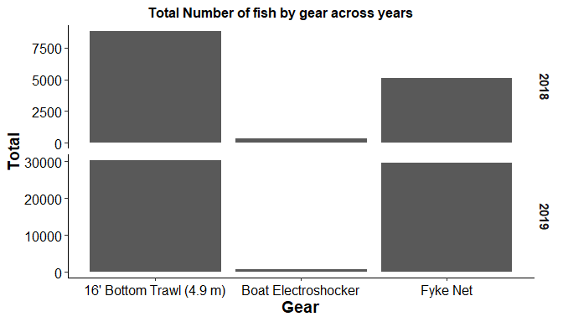

Figure 1. An example of a figure that was created using ggplot.